AP English Summer Reading List for 2016-2017 school year.
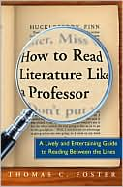
You will read the first three books listed here. I suggest you read How to Read… first. Download the template from my website. Update it for each chapter and fill it in as you read this summer and then add to it as you read during the year. Foster’s book will help you with the next two. Then, read in whichever order you desire. Please keep a reader’s journal for the two fiction pieces. Note recurring themes, questions that arise, character motivations, desires, etc. that you find interesting. Once you have read a book, complete an AP Journal for books following the template. These books are yours to keep and you should treat them as such. That means annotating and writing in the books to help you locate passages, piece important ideas together, and help you gain a deeper understanding of the work. You may find the templates on my website: mrsgugerty.weebly.com. Work is due on August 17, 2016.

How to Read Literature Like a Professor by Thomas C. Foster
• Paperback: 336 pages
• Publisher: Harper Paperbacks; 1 edition (February 18, 2003)
• Language: English
• ISBN-10: 006000942X

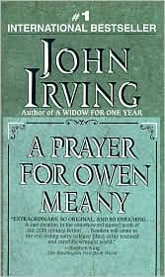
A Prayer for Owen Meany by John Irving
• Paperback: 617 pages
• Publisher: Random House Publishing Group
• Language: English
• ISBN-10: 0345361792

The Kite Runner by Khaled Hosseini
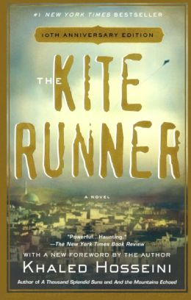
• Paperback: 371 pages
• Publisher: Riverhead Books
• Language: English
• ISBN-13: 978-1-59463-193-1

Early in the fall, we will read A Tale of Two Cities. I request you purchase this book as well as it goes along with our annotation and you should have your own copy to learn to annotate well. This particular edition has an excellent notes section in the back.
A Tale of Two Cities by Charles Dickens
• Paperback: 372 pages
• Publisher: Barnes and Noble Classics
• Language: English
• ISBN-10: 1-59308-138-3

I request you purchase the paperbacks as described here as then we will all have the same copy. This will help in referencing passages and in class discussion. The Kite Runner has discussion questions at the back that I will expect you will have explored on your own or with others in the class.
These books may be ordered through barnesandnoble.com or, with the exception of Tale of Two Cities, amazon.com. You may also ask they order these versions at the Barnes & Noble in Joliet.

See you in August! --Mrs. Gugerty

